REst API in SpringBoot

**->Create a simple RESTful service in Spring Boot which returns the Response "Welcome to spring boot".**

**--** <http://localhost:8080/firstApplication>

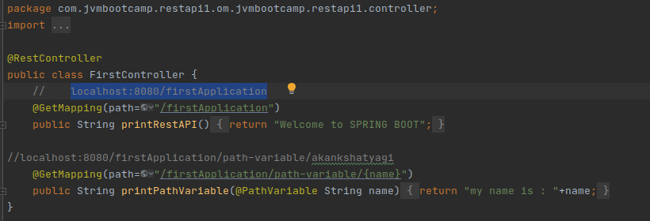

Output :

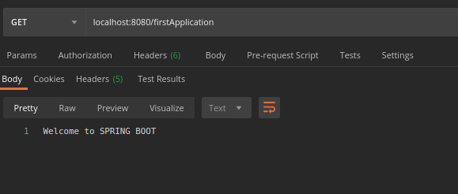

**->Create an Employee Bean(id, name, age) and service to perform different operations related to the employee.**

Employee.java

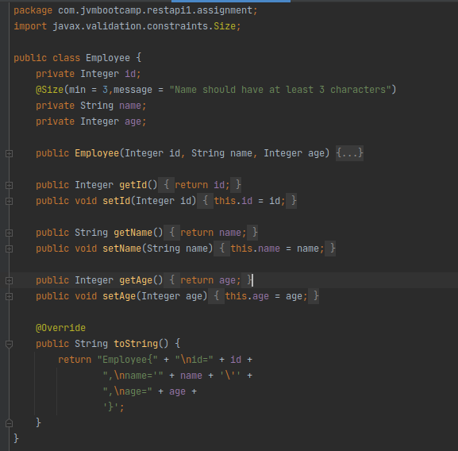

EmployeeDAO/EmployeeCrudoperations.java :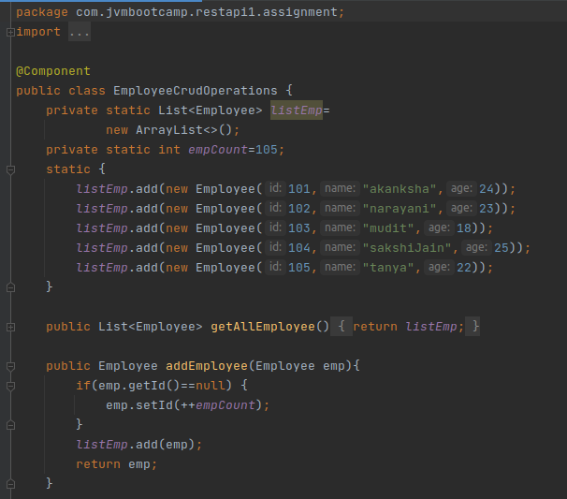

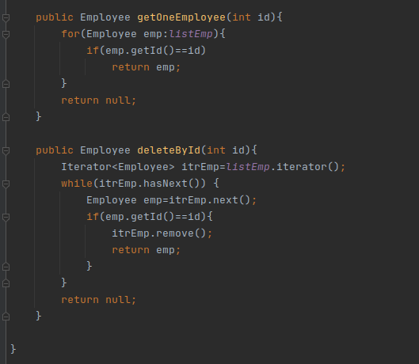

**-> Implement GET http request for Employee to get a list of employees.**

EmployeeController.java

-- <http://localhost:8080/retrieveEmployee>

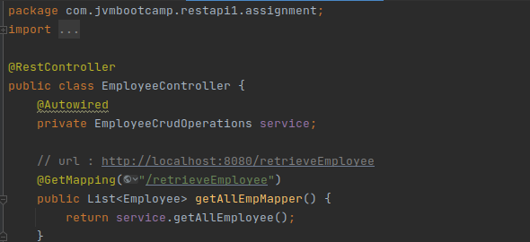

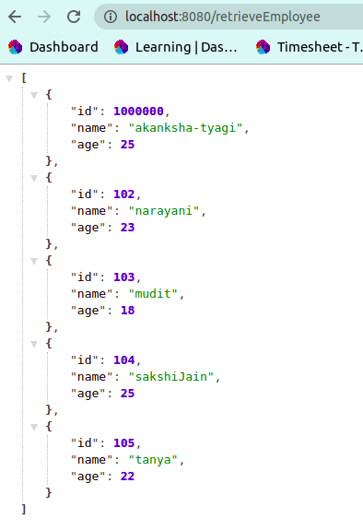

**->Implement GET http request using path variable top get one employee:**

<http://localhost:8080/retrieveEmployee/101>

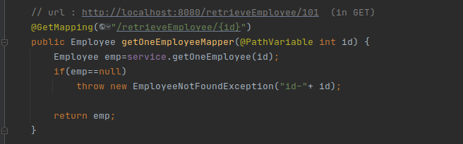

**Output:** 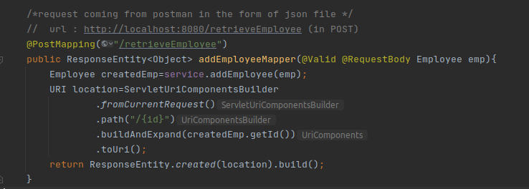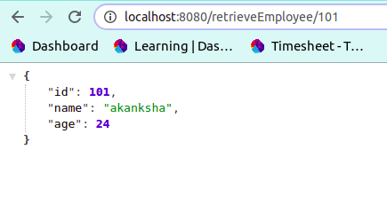

**->Implement POST http request for Employee to create a new employee.**

<http://localhost:8080/retrieveEmployee> (in Post method)

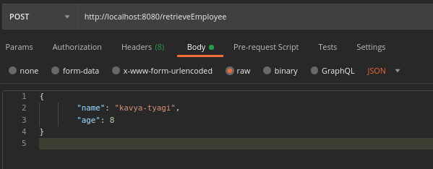

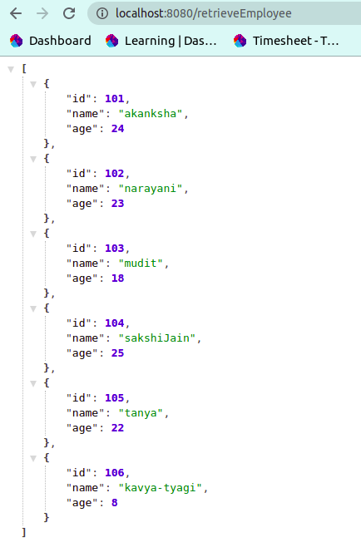

**->Implement Exception Handling for resource not found**

-- <http://localhost:8080/retrieveEmployee/10000>

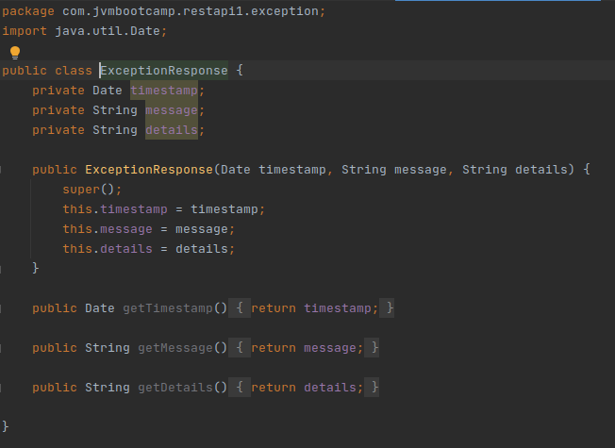

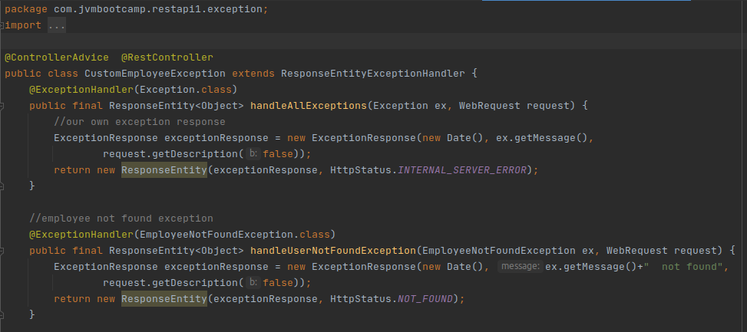

**output:**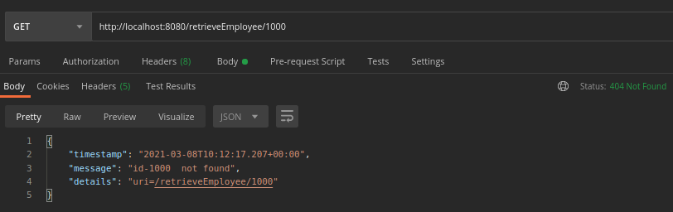

**->Implement DELETE http request for Employee to delete employee**

-- <http://localhost:8080/retrieveEmployee/101> (in delete method)

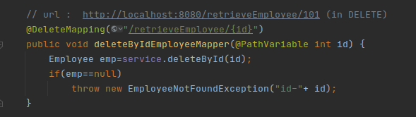

**Output:** 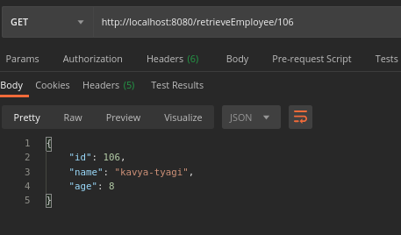

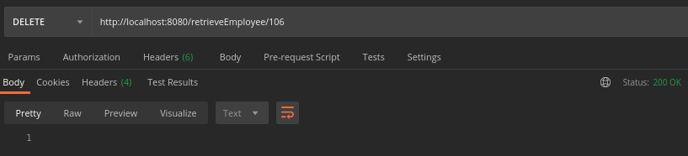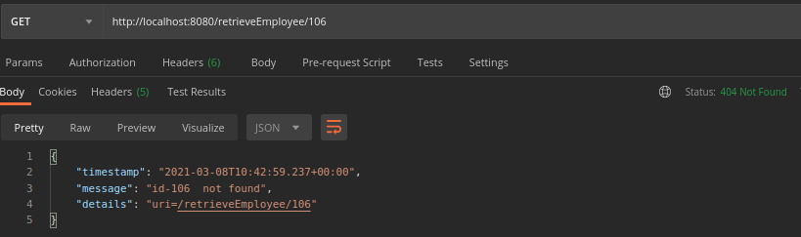

**->Implement PUT http request for Employee to update employee**

-- <http://localhost:8080/retrieveEmployee/101> (in put method)

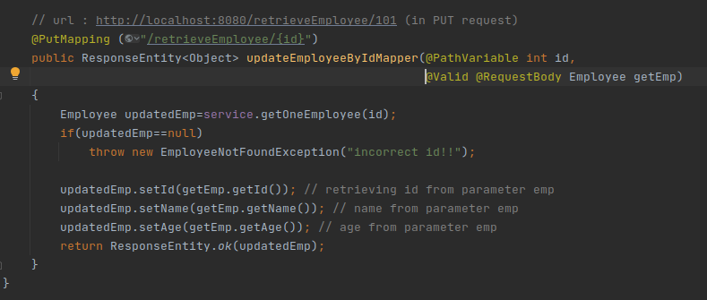

**Output:**

**Creating employee:**

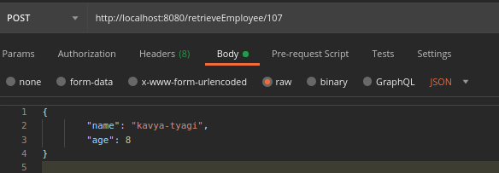

**getting employee:**

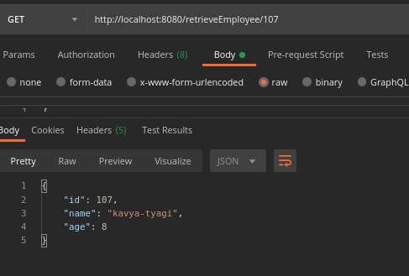

**updating employee:**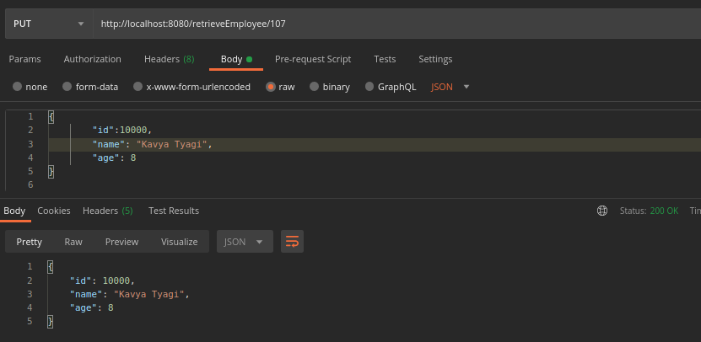

**->Apply validation while create a new employee using POST http Request.**

-- <http://localhost:8080/retrieveEmployee> (in post method)

--Validation fails

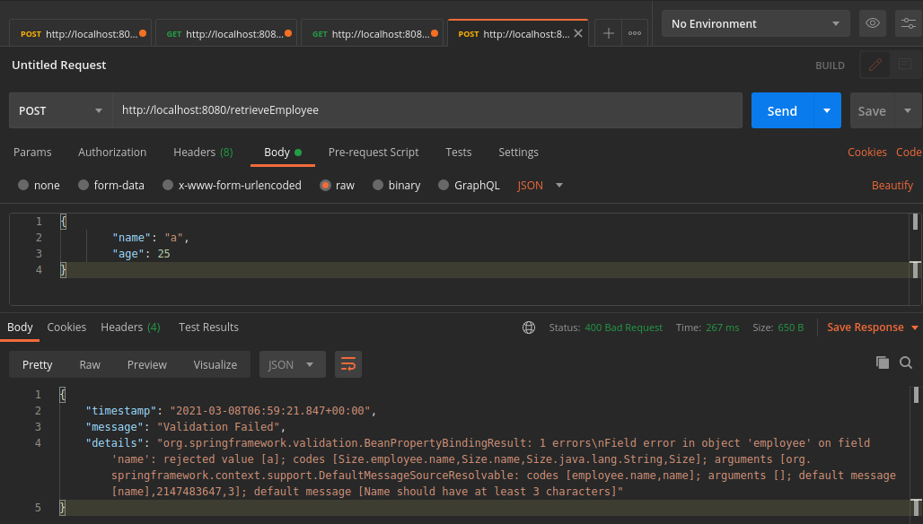

--Validation passes:

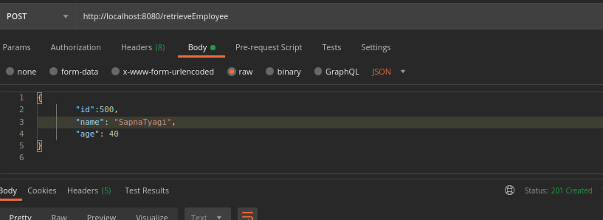

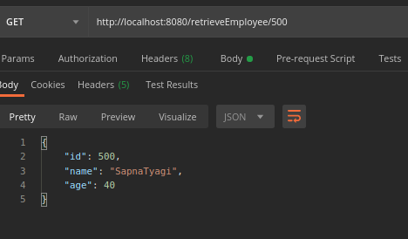

**->Configure actuator in your project to check the health of application and get the information about various beans configured in your application.**

Added dependency in pom.xml

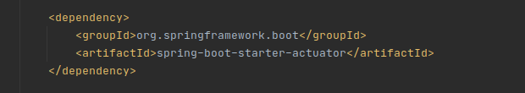

<http://localhost:8080/actuator>

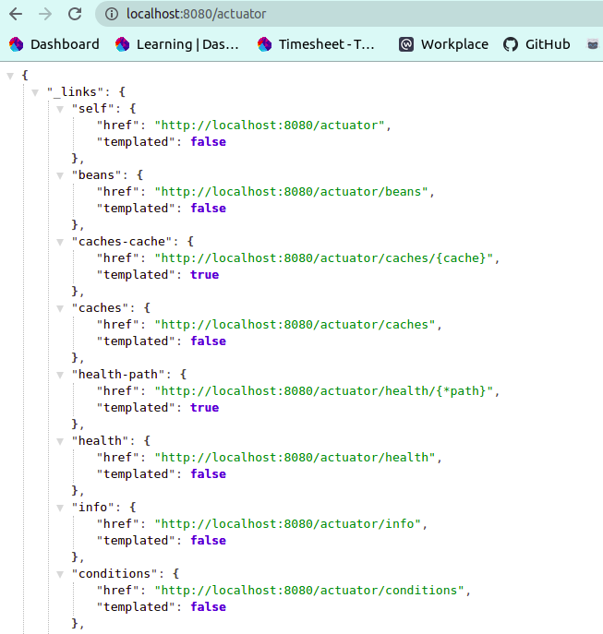

<http://localhost:8080/actuator/health> 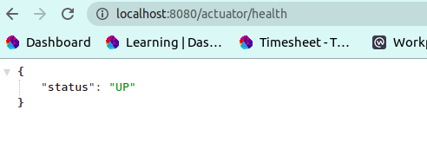

Beans configured: <http://localhost:8080/actuator/beans> 